**Week 10 Topic Outline – Finite State Machines and Game Agent AI**

1. **Finite State Machines**
   1. Computational model that is defined by a list of its states, and the triggering condition for each transition.
   2. There are a finite number of states
   3. The machine is in only one state at a time (current state)
   4. Example – a turnstile:

|  |  |  |  |
| --- | --- | --- | --- |
| **Current State** | **Input** | **Next State** | **Output** |
| **Locked** | coin | Unlocked | Release turnstile so customer can push through |
| push | Locked | None |
| **Unlocked** | coin | Unlocked | None |
| push | Locked | When customer has pushed through lock turnstile |

* 1. Entry Action – performed when the state is entered
  2. Exit Action – performed when the state is exited
  3. Example: a toaster oven

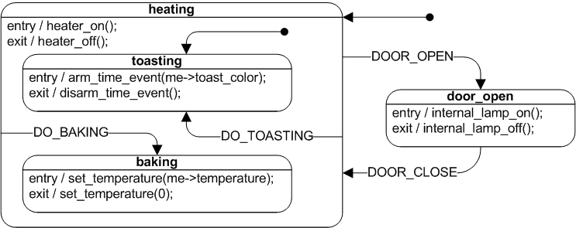

* 1. Example Game FSM:

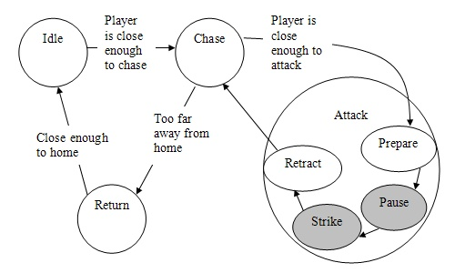

1. Look at this awful paintball game
   1. [www.axis-games.com/paintball.php](http://www.axis-games.com/paintball.php)
   2. Play for a few minutes
   3. Draw a Finite State Machine with transitions to represent the Computer Agent.
2. Break
3. Finite State Machines in Sports Games